FINTECH TRANSACTION SECURITY
Modular Assignment 4 | Security Solution
Md Habib Ahmed | IHC – Cloud Development | October 2026

1. Objective and security requirements
A mid-sized fintech requires a demonstrable security strategy for financial transaction data. This prototype addresses confidentiality through AWS Key Management Service (KMS), identity verification through signed JWTs, least-privilege access through application roles and AWS IAM, and detection through analysis of simulated security events. Data, application and cloud-permission threats are treated separately.

2. Architecture and deployment approach
The Python application runs locally or in AWS CloudShell. It reads Customer_Transactions.csv and Threat_Log.json, validates a short-lived HS256 JWT, applies viewer/analyst/admin permissions, writes Threat_Analysis.json and optionally invokes AWS KMS in eu-north-1 to encrypt and decrypt one sample transaction. Separately, AWS STS was used in CloudShell to assume FintechTransactionReader and validate its kms:Decrypt-only IAM policy. No hosted web API or automatic STS assumption is claimed.
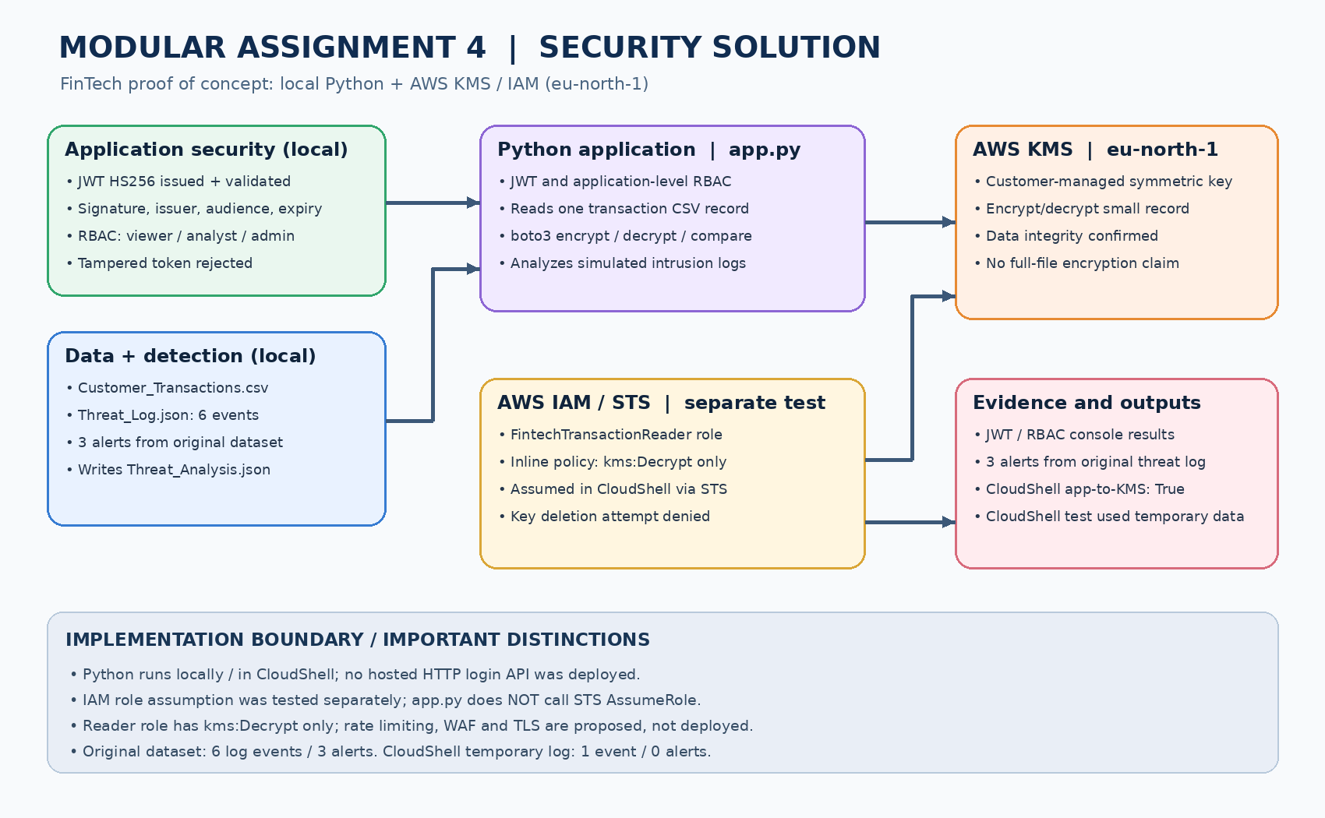
Figure 1. Implemented application modules and separately validated AWS IAM/KMS controls.

3. Implemented security controls
JWT: HS256 signature, issuer, audience and expiration are validated; a modified token is rejected. Application RBAC: viewer=read, analyst=read/analyze, admin=read/analyze/manage. AWS KMS: boto3 encrypts and decrypts a serialized sample CSV record and checks byte-for-byte equality. The reader IAM role was verified to decrypt, while scheduling key deletion was denied.

4. Threat analysis and mitigations
The original six-event Threat_Log.json produces three alerts: three failed logins from one IP (brute-force indicator), one access_denied event (authorization failure), and one suspicious_payload event (application-layer risk). The script outputs a console dashboard and Threat_Analysis.json. Rate limiting, temporary IP blocking, input validation and AWS WAF are recommended mitigations, not deployed enforcement.
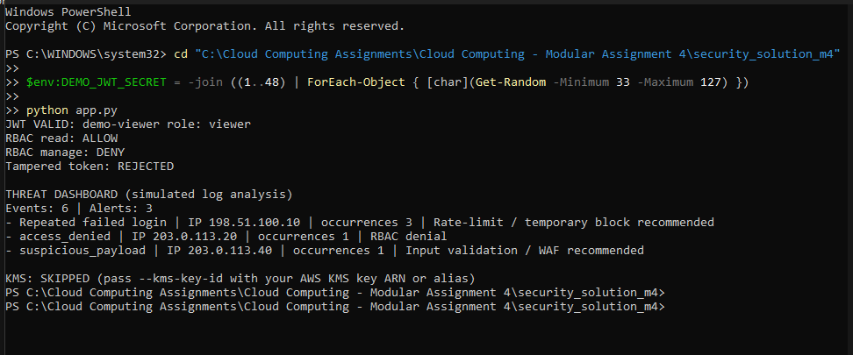
Figure 2. Local JWT/RBAC checks and threat dashboard: six events, three alerts.

5. AWS encryption and identity evidence
A customer-managed symmetric KMS key was created in AWS Stockholm. AWS CLI encrypt/decrypt and a boto3 round trip succeeded. The separate FintechTransactionReader role was assumed using STS; it decrypted ciphertext but could not schedule key deletion, demonstrating permission separation.
Figure 3. AWS SDK (boto3) KMS encryption, decryption and integrity validation.
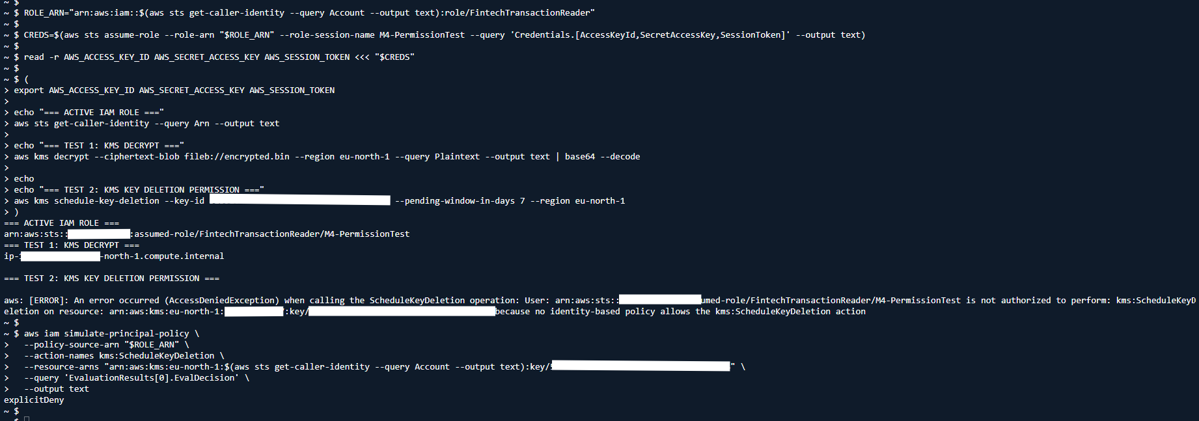
Figure 4. Assumed IAM reader role: decrypt allowed; key deletion denied.

6. End-to-end validation and test summary
The actual app.py was executed in AWS CloudShell with a temporary sample CSV and a one-event threat log. JWT authentication, application RBAC, token-tampering rejection and AWS KMS integration all ran successfully. The output confirmed 249 ciphertext bytes and “AWS KMS decryption matches original: True”. Because the CloudShell threat log was a temporary one-event sample, it reported zero alerts; the original six-event log was separately tested locally and produced three alerts.
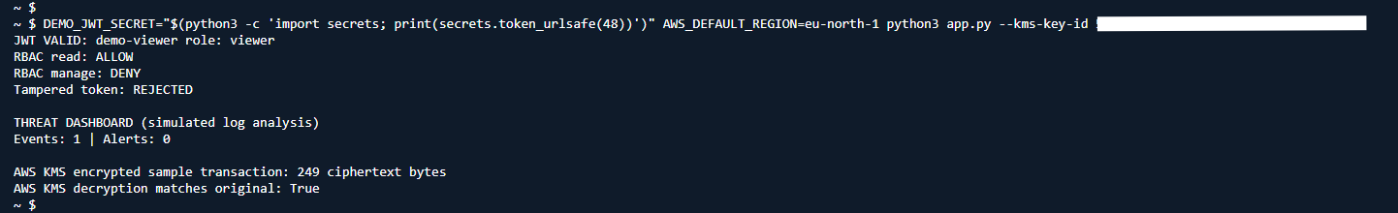
Figure 5. Full app.py execution against live AWS KMS using temporary test datasets.

7. Security validation matrix
JWT authentication and tampering | Valid viewer JWT accepted; altered token rejected
Application role authorization | Viewer read ALLOW; manage DENY
Threat detection on original dataset | 6 events analyzed; 3 alerts emitted
KMS cryptography and integrity | AWS CLI, boto3 and complete app.py tests passed
AWS IAM least privilege | Reader assumed via STS; decrypt allowed; key deletion denied

8. Limitations, cost and conclusion
This is a demonstrator, not a production-deployed transaction API. The code encrypts one transaction record, not the entire CSV; the local threat dashboard does not automatically block IPs or deploy a WAF. JWT secrets are supplied through an environment variable, not embedded in source. A customer-managed KMS key may incur charges until scheduled for deletion; evidence should be retained before resource cleanup. The tests establish working authentication, authorization, threat detection, and AWS-backed encryption with clearly scoped limitations.

9. Reproducibility and evidence
The accompanying repository contains app.py, requirements.txt, both synthetic datasets, Threat_Analysis.json, architecture diagram, README.md and AWS evidence screenshots in docs/. The README provides execution instructions and links to the complete evidence set.

